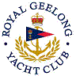 | Royal Geelong Yacht Club Inc.  Est 1859
Trophy Deed of Gift.

Trophy: | Perpetual Trophy for Classic Yachts: Series Aggregate
Presented by: | R. A. N. R. (Geelong)
Date:
For: | Wooden Boat Festival
Remarks / Revisions
Click here for a List of Recipients

